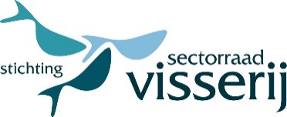
Certificate
national and international fishermen
travelling to and from their fishing vessels
Communication from the European Commission
C(2020) 2051 final of 30 March 2020
Guidelines concerning the exercise of the free movement of workers during COVID-19 outbreak

It is hereby confirmed that the following person(s) carries/carry out the vital profession of fisherman providing essential seafood within the European Union and internationally and is/are therefore entitled to smooth transport and smooth border crossing(s) within the European Union:

Name and surname(s) | Birthdate | Place of Residence

At the request of an authorized person the above mentioned person(s) shall produce one’s valid seaman’s book or similar official document.

Place of issue
Date of issue
Name of issuing organization
Name of signatory
Signature | Place signature below this point

